5 April 2024 1BM21CS086

**Lab 1 : Importing and Exporting Data using Pandas**

**Algorithm Screenshot**

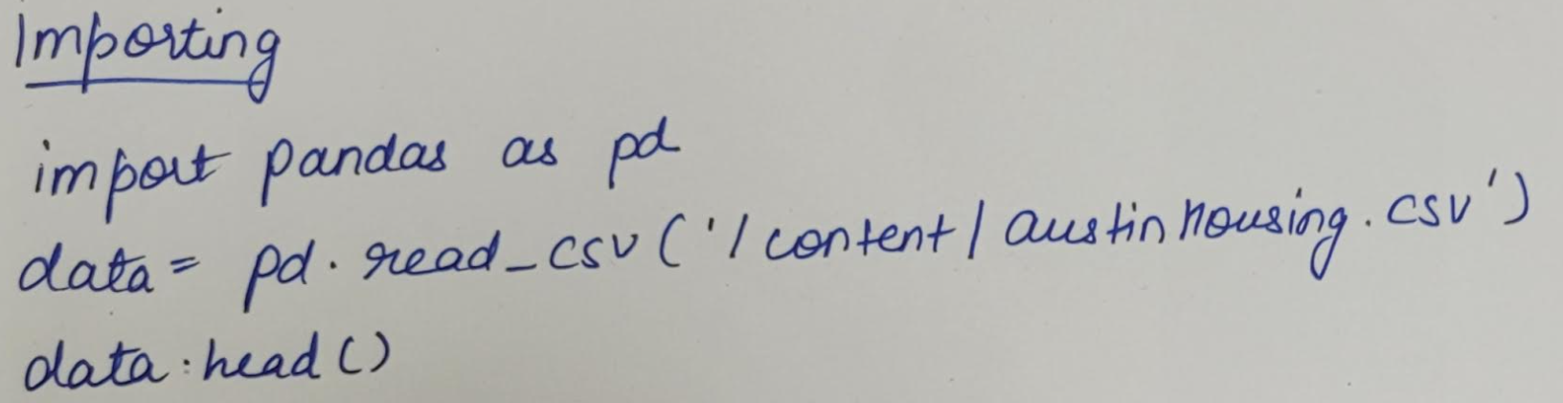

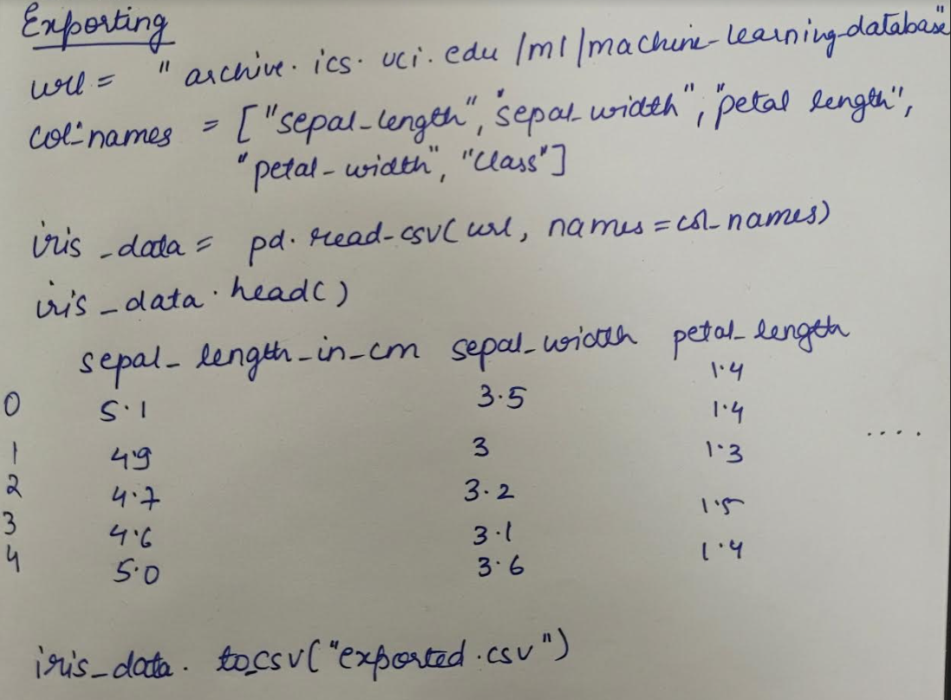

**Code Screenshot**

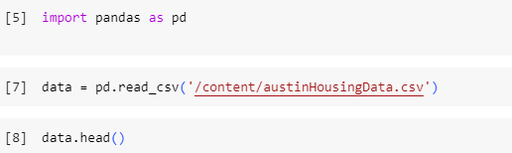

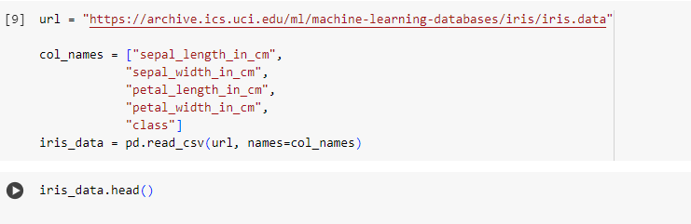



**Output:**

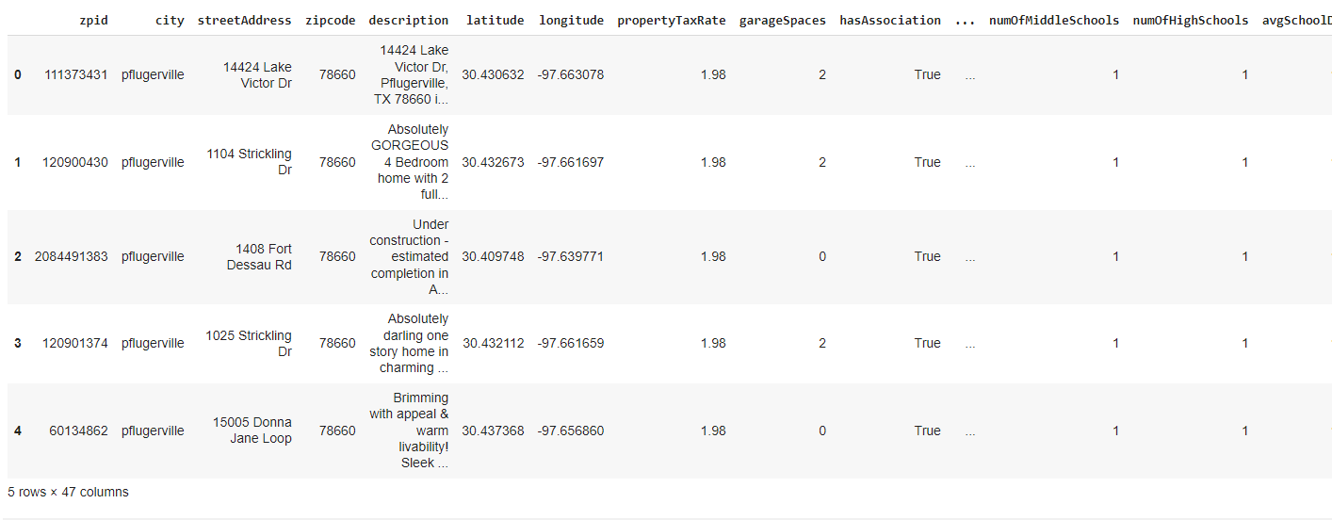

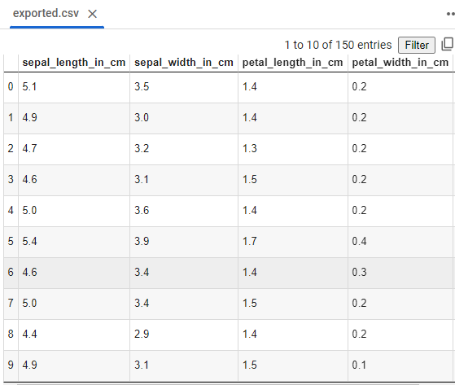

5 April 2024 1BM21CS086

**Lab 2 : Demonstrate various data pre-processing techniques for a given dataset**

**Algorithm Screenshot**

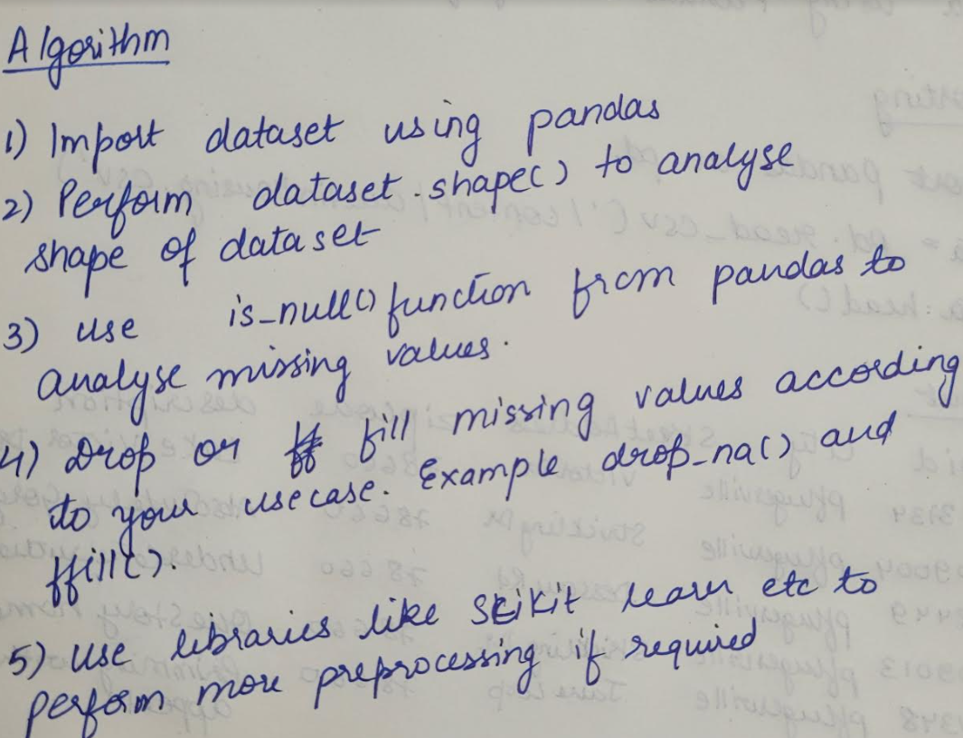

**Code Screenshot and Output:**

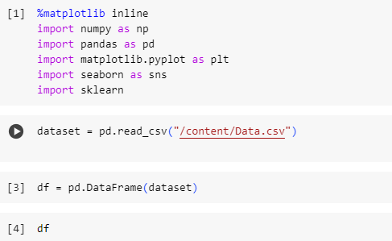

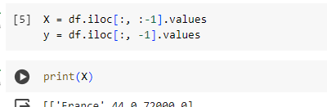

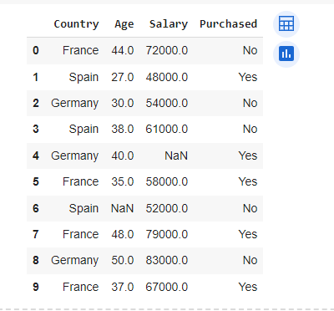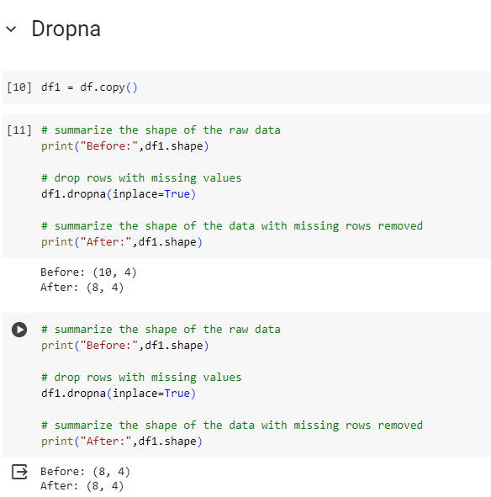

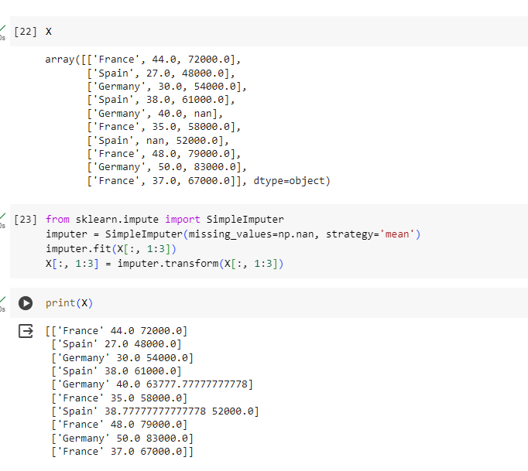

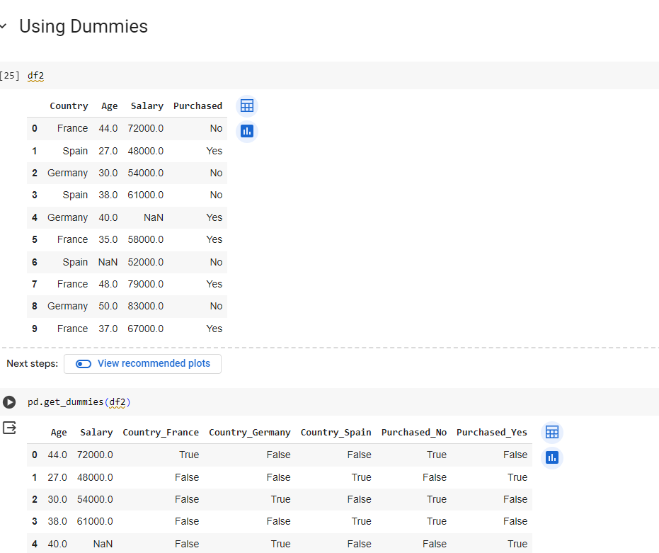

12 April 2024 1BM21CS086

**Lab 3: Building ID3 and Applying the knowledge to classify a new sample**

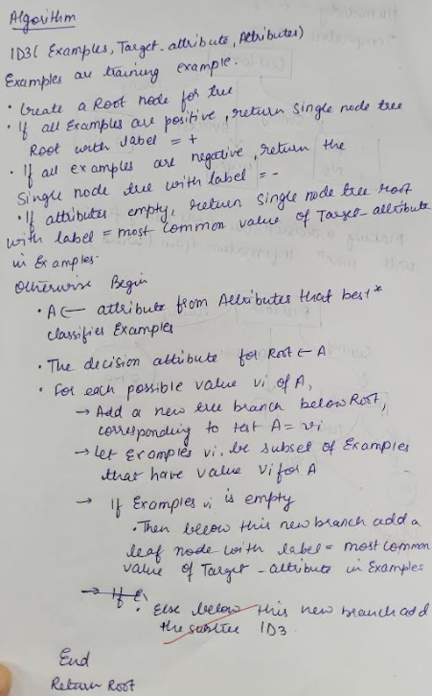**Algorithm Screenshot**

**Code Screenshot and Output:**

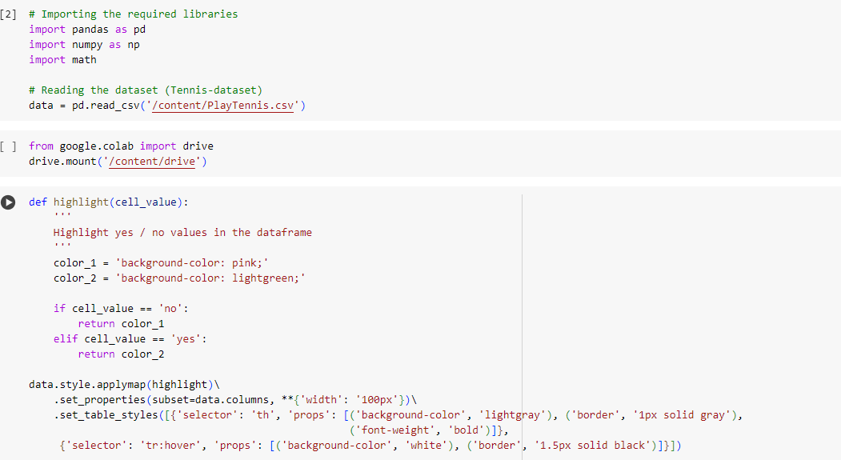

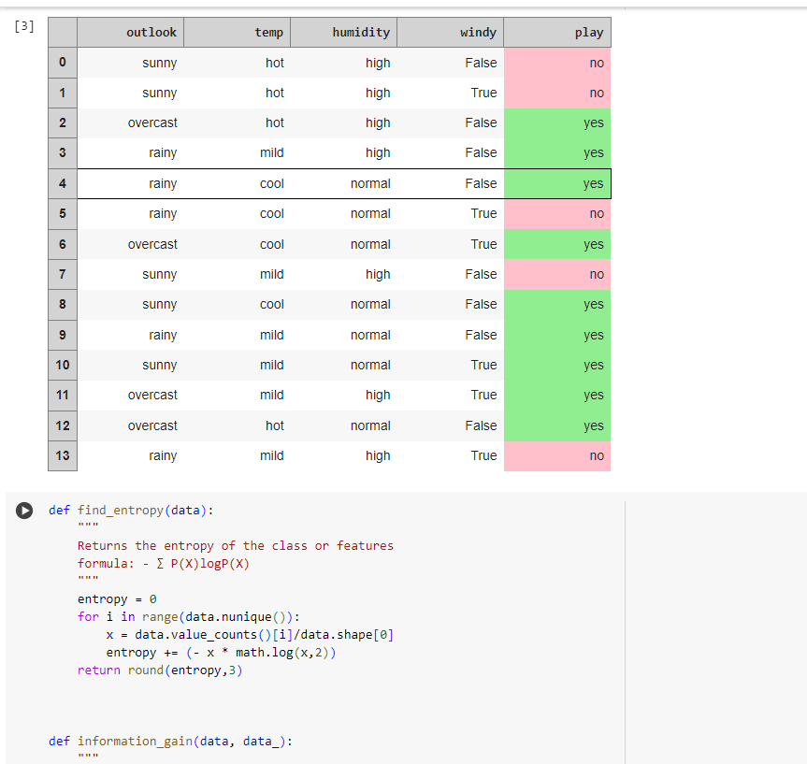

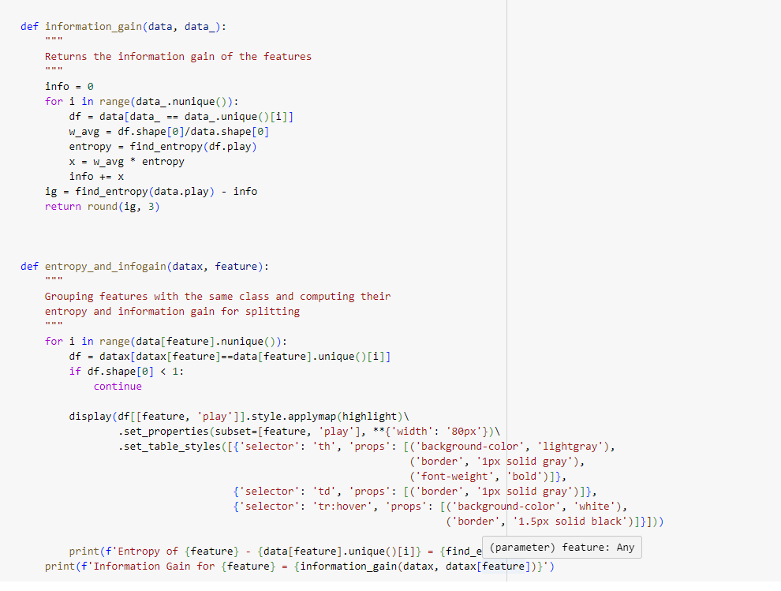

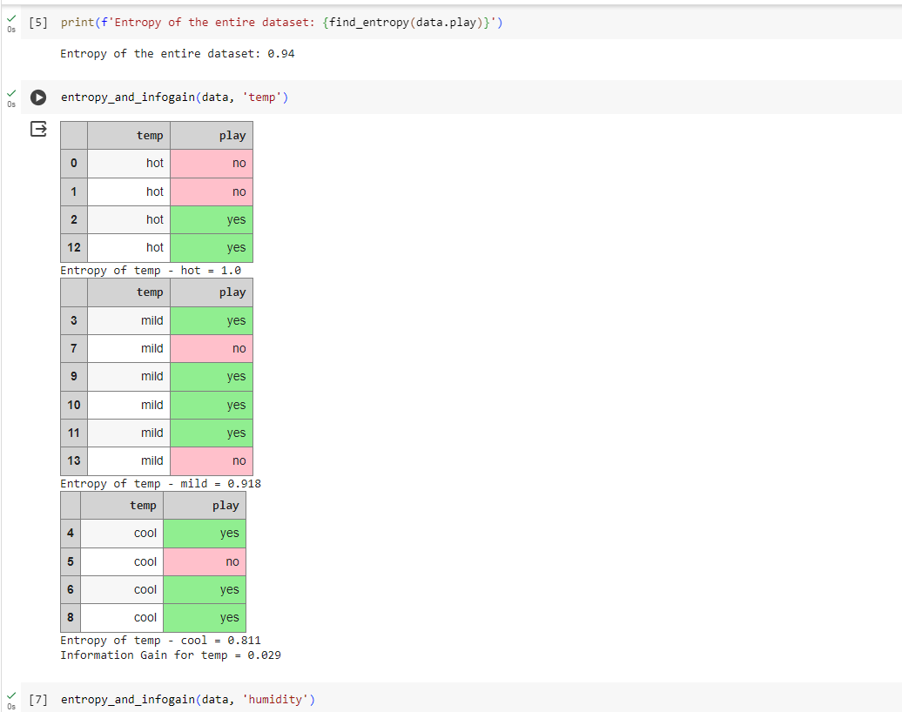

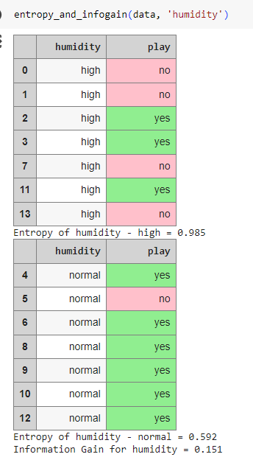

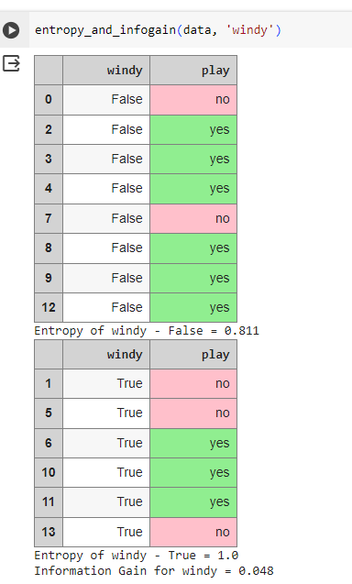

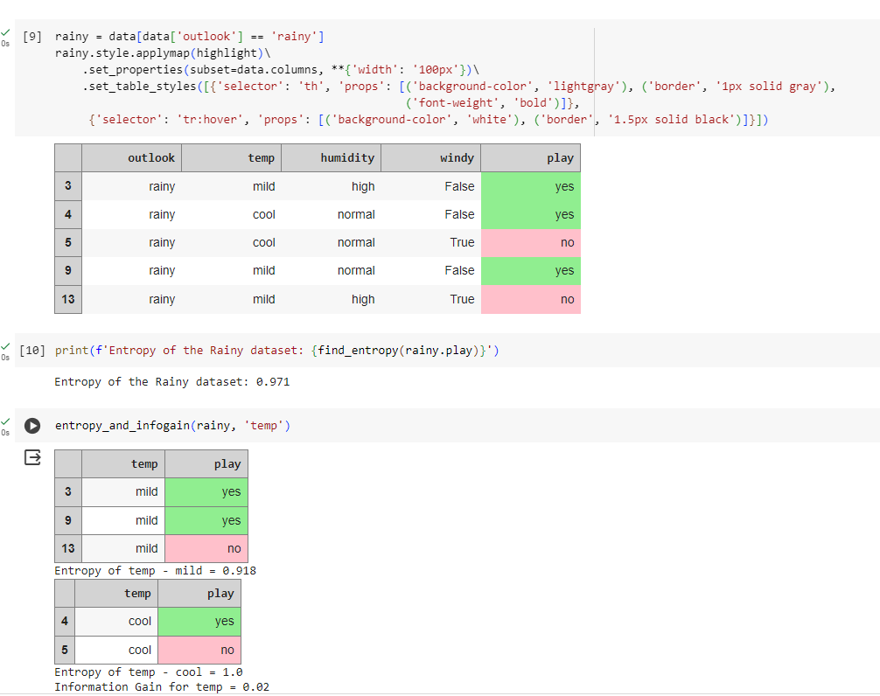

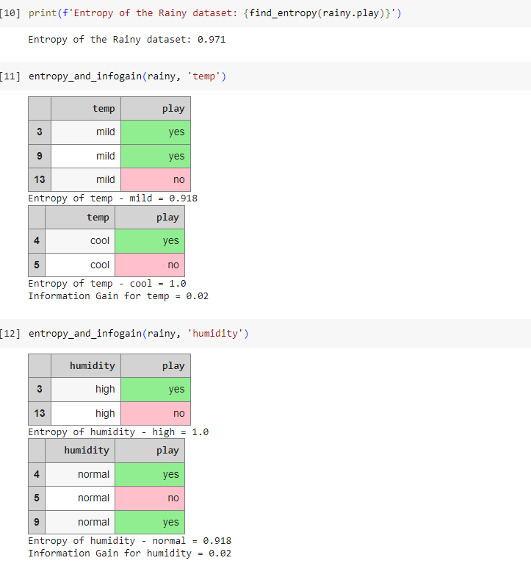

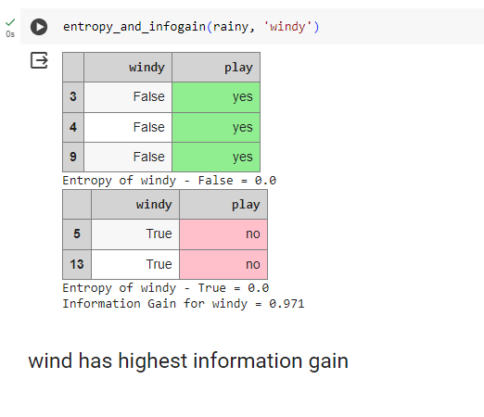

**Output:**

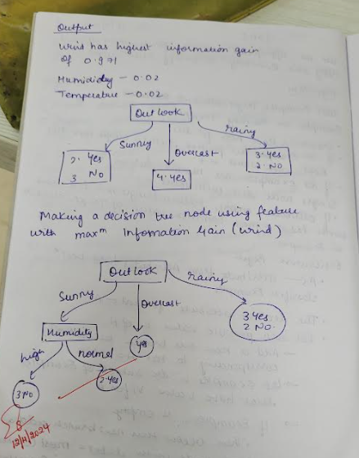

19 April 2024 1BM21CS086

**Lab 4 :Implement Linear and Multi-Linear Regression algorithm using appropriate dataset**

**Algorithm Screenshot**

**Code Screenshot and Output:**

19 April 2024 1BM21CS086

**Lab 5: Build KNN Classification model for a given dataset.**

**Algorithm Screenshot**

**Code Screenshot and Output:**

